Patch Hist

i hate drab and gloomy images, i like bright and colorful images, that was the first reason i wanted to try and make "patch hist". in this work i want to explore image manipulations that gives the image the most and best colors while preserving the image content.

For this i decided to take the route of histogram manipulation. In the area of histogram manipulation i decided that the ideas of histogram equalization is the best answer to the task of giving the image the most colors it can have while preserving the image content.

While basic histogram equalization gives us the answer globally, i would like it more if every part of the image would have our desired qualities on his own. So from this we come to "patch hist" which entails preforming histogram equalization on every patch of the image and blending the results.

In essence what i try to do is to maximize the dynamic range in each sub-patch of the image.   
There was a previous algorithm to try and make these results called CLAHE (Contrast-limited adaptive histogram equalization), but being from 1994 things where needed to be done to consider the limits of the computing power back then, and i believe that "patch hist" is closer to the true answer if computing power is not a problem.

In this work i will compere basic histogram equalization, CLAHE and my "patch hist".

**Note:** for equal comparison default CLAHE form openCV was used and "patch hist" was made to work on the same patch size as CLAHE.

For the testing a friend couple Dana and Zeev montekyo donated both their images and images of one of their homes.

LAB vs RGB

Because the algorithms natively work on grayscale images, and not color images, there is a need for an extension for color images like we want.

For this i check two main methods:

* Transform the image from RGB-image to LAB-image, do the manipulations on the L layer of the image.   
  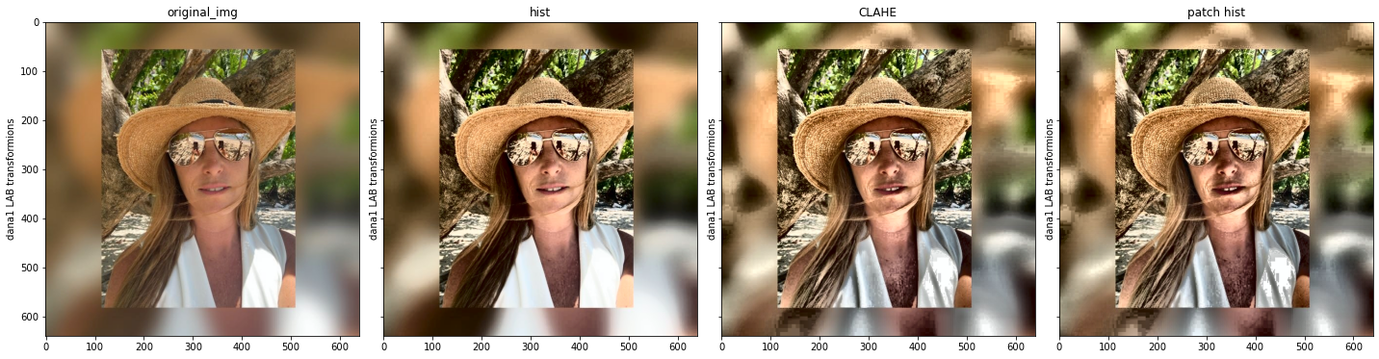  
  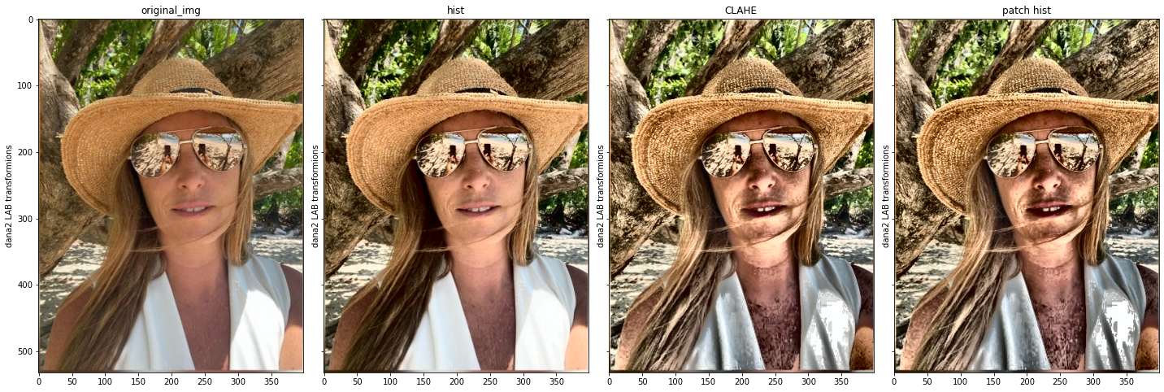  
  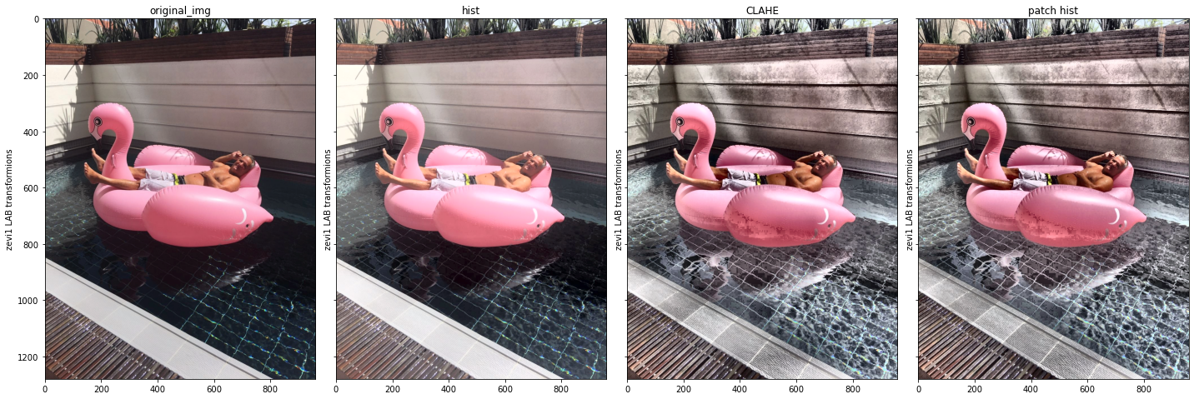  
  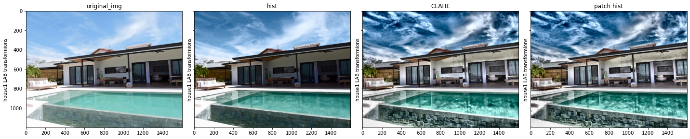  
  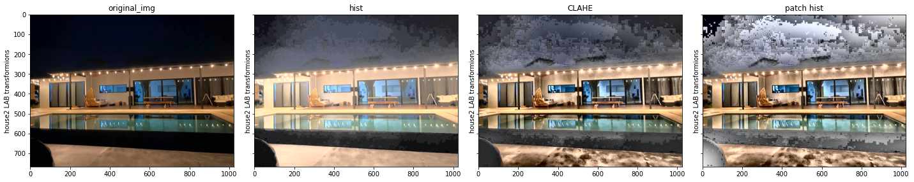
* Use the RGB-color image as input and work on all layers separately   
  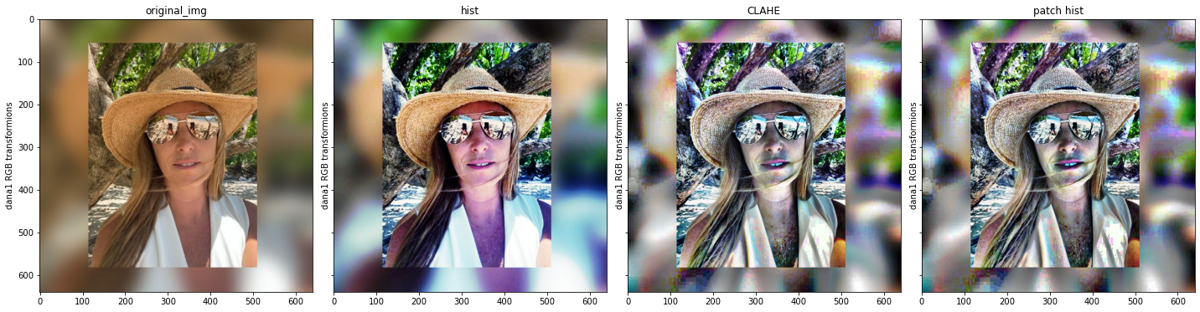  
    
  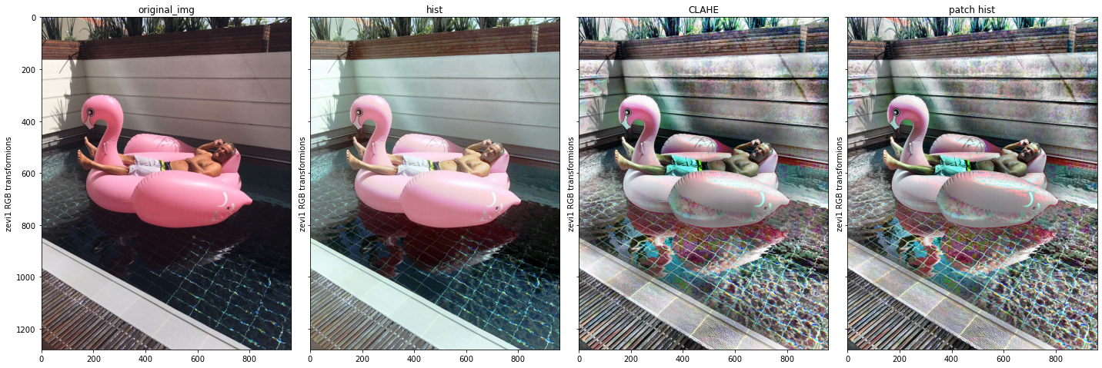  
  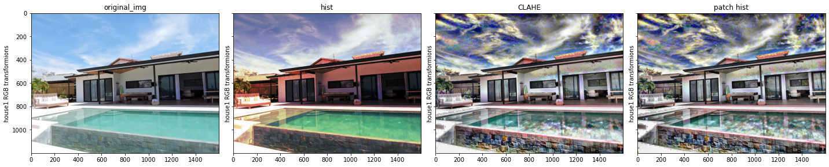  
  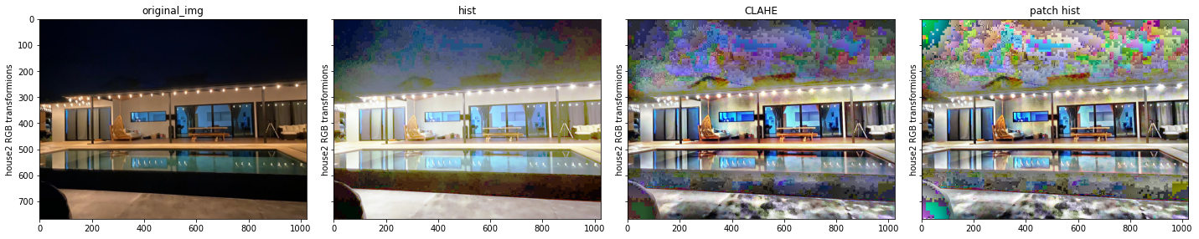

from the results it looks like the LAB manipulation look more natural and easier on the eyes, and the RGB manipulation may look more artistic and colorful.

These results may come from the theory of light, that says that light have 3 parameters: amplitude(strength), wavelength(color) and polarization(that normal cameras don't measure). so doing the LAB manipulation works on equalizing amplitudes as a whole, while doing the RGB manipulation works on equalizing amplitudes of specific wavelengths.

Histogramic Results

For deeper look on the results we can look on the histograms of the images. The histograms were scored for uniformity with the formula of standard deviation of the histogram bins sizes divided by mean bin size, where lower score is better.

Histograms of the LAB images

dana1

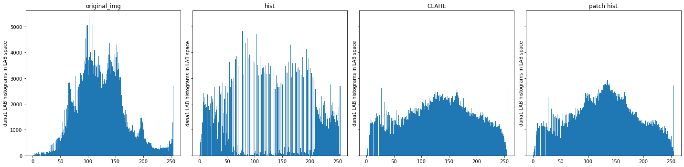

{'original_img': [0.8734049146985212], 'hist': [0.8682627553928267], 'CLAHE': [0.32422827546248184], 'patch hist': [0.3977195699525511]}

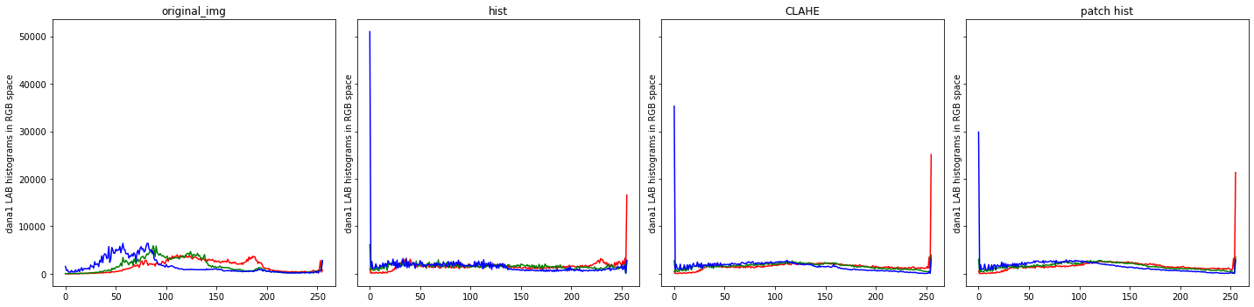

{'original_img': [0.7744933, 0.92820543, 1.0261638], 'hist': [0.69223094, 0.3102404, 1.9774493], 'CLAHE': [0.983815, 0.34999043, 1.4003537], 'patch hist': [0.8717559, 0.4259408, 1.2273544]}

dana2

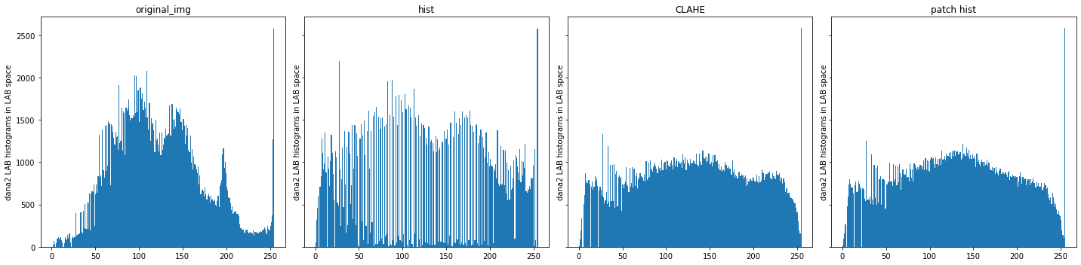

{'original_img': [0.7076750960046018], 'hist': [0.7205649171814782], 'CLAHE': [0.2846826886135755], 'patch hist': [0.31130301163957425]}

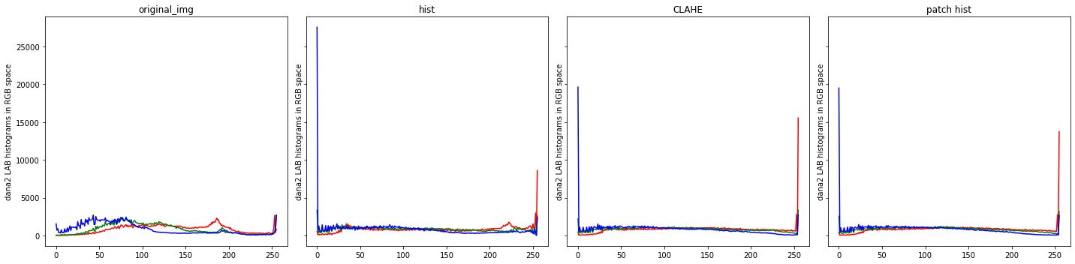

{'original_img': [0.6369641, 0.78024256, 0.86981934], 'hist': [0.6986702, 0.3410235, 2.0590358], 'CLAHE': [1.157757, 0.3424125, 1.485687], 'patch hist': [1.031971, 0.37693232, 1.4865389]}

zevi1

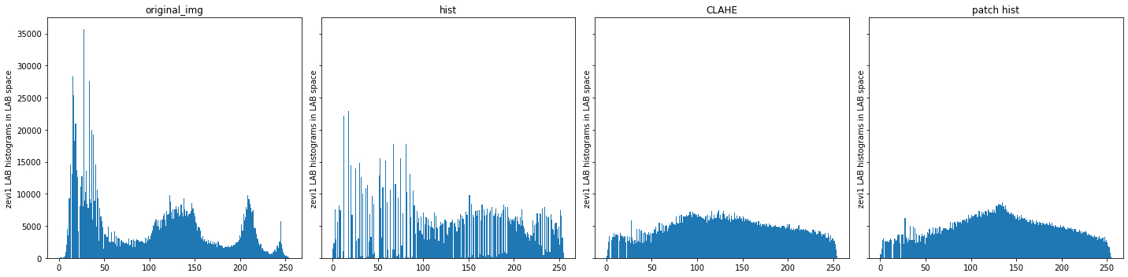

{'original_img': [0.9890852589411857], 'hist': [0.840953232351729], 'CLAHE': [0.3082106304536062], 'patch hist': [0.3599756199622843]}

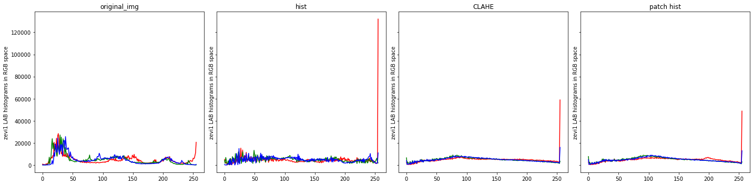

{'original_img': [0.8810583, 0.945195, 0.9677271], 'hist': [1.7025295, 0.41660678, 0.47362956], 'CLAHE': [0.7596756, 0.35699436, 0.38143137], 'patch hist': [0.65524447, 0.3947794, 0.4067655]}

house1

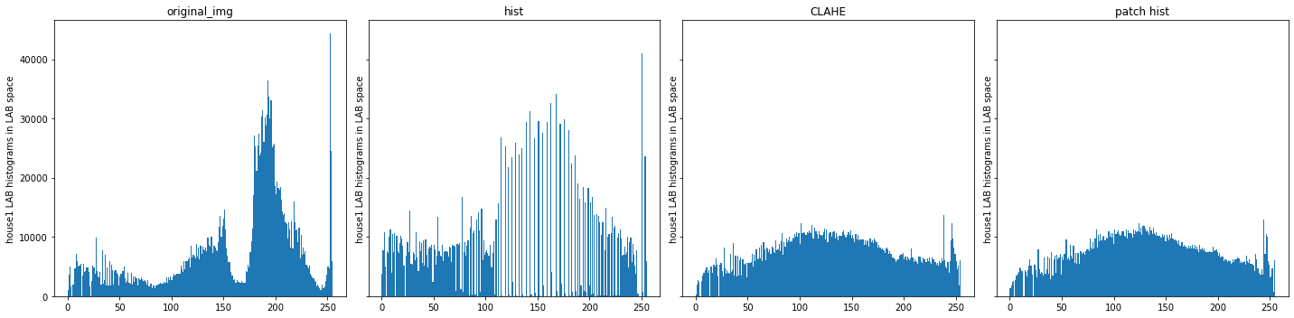

{'original_img': [1.0230246022484286], 'hist': [1.058458535770034], 'CLAHE': [0.3395633427653816], 'patch hist': [0.35033285977608336]}

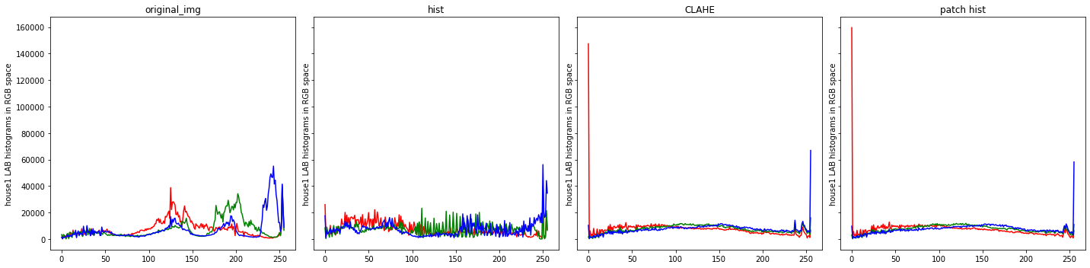

{'original_img': [0.8275342, 0.9598629, 1.2345413], 'hist': [0.66759336, 0.60812765, 0.7968576], 'CLAHE': [1.2150788, 0.35095027, 0.5833628], 'patch hist': [1.3157395, 0.3482213, 0.5265109]}

house2

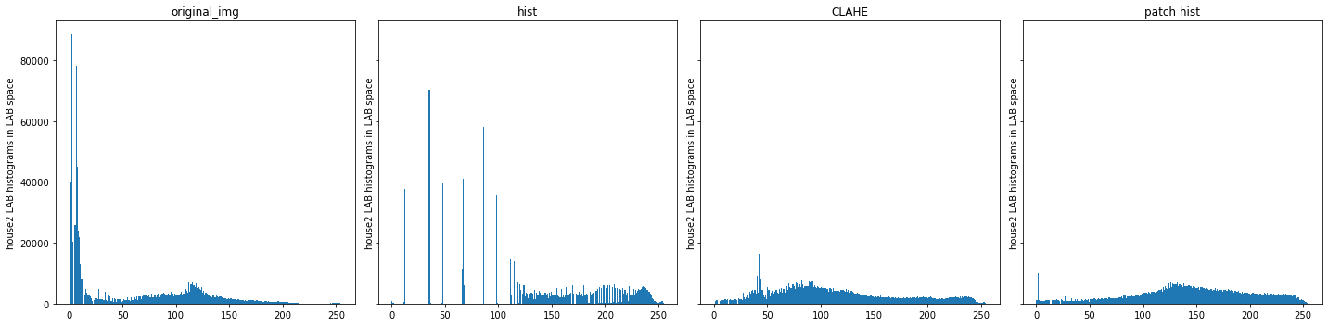

{'original_img': [2.789456337608467], 'hist': [2.4681986610280653], 'CLAHE': [0.6734558532969469], 'patch hist': [0.5555957624833572]}

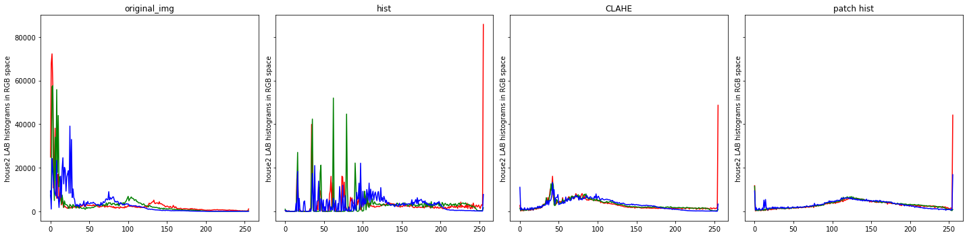

{'original_img': [2.5101812, 2.345188, 1.7164646], 'hist': [2.092851, 1.9422308, 1.1473175], 'CLAHE': [1.1815387, 0.71994567, 0.7756188], 'patch hist': [0.9862966, 0.5493743, 0.6190098]}

Histograms of the RGB images

dana1

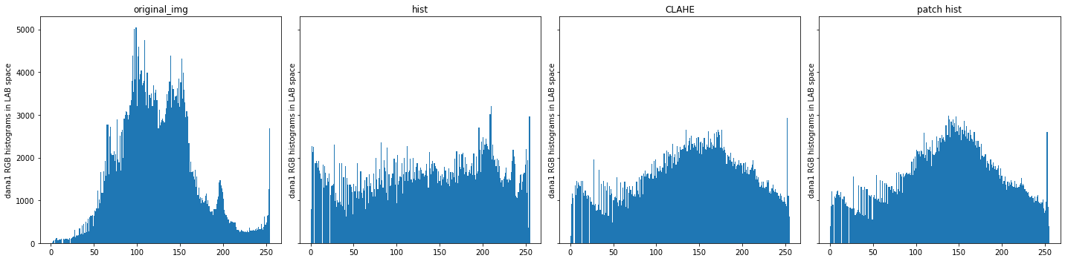

{'original_img': [0.8682730167500375], 'hist': [0.2728050722070156], 'CLAHE': [0.343551491866178], 'patch hist': [0.40501189037811747]}

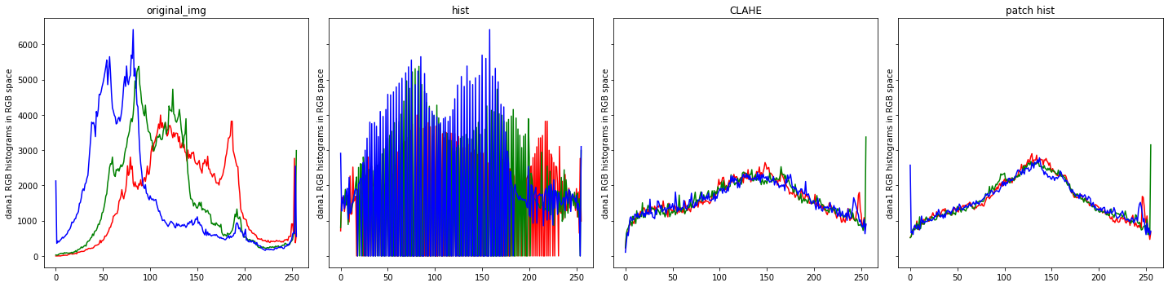

{'original_img': [0.77244264, 0.9227254, 1.0087031], 'hist': [0.82701325, 0.98151237, 1.0826805], 'CLAHE': [0.28984398, 0.28759822, 0.2675146], 'patch hist': [0.37484565, 0.36621702, 0.33552918]}

dana2

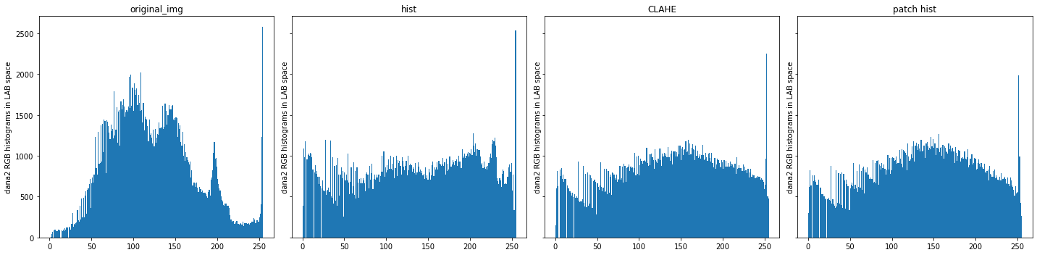

{'original_img': [0.7015764898116661], 'hist': [0.2649988963797387], 'CLAHE': [0.27293716635999404], 'patch hist': [0.2938762653333984]}

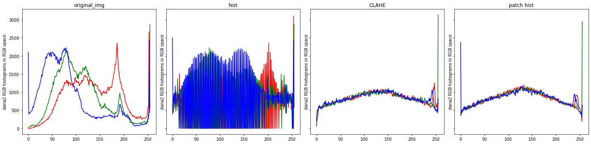

{'original_img': [0.63349193, 0.7766938, 0.85494643], 'hist': [0.70401114, 0.8549057, 0.93701524], 'CLAHE': [0.19101419, 0.25335953, 0.18816328], 'patch hist': [0.23063135, 0.27834395, 0.23889275]}

zevi1

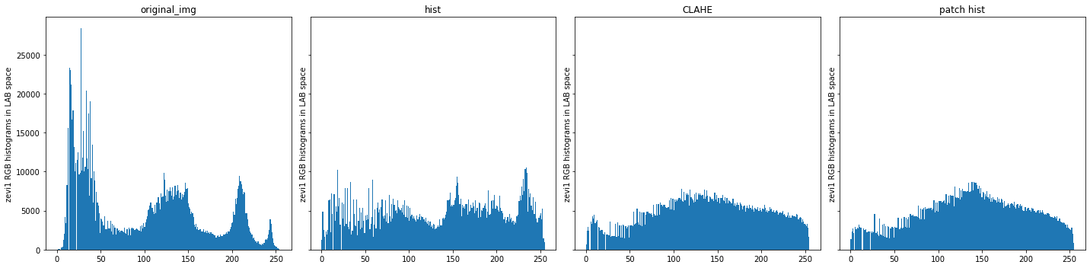

{'original_img': [0.9132380286842241], 'hist': [0.36289235550059823], 'CLAHE': [0.34249665913804883], 'patch hist': [0.39050813833546194]}

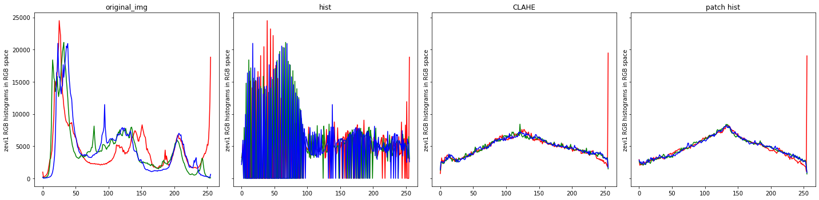

{'original_img': [0.8255931, 0.89568764, 0.9391347], 'hist': [0.9136498, 0.960381, 1.0003679], 'CLAHE': [0.34504926, 0.27883175, 0.27200344], 'patch hist': [0.38884482, 0.33494177, 0.32817507]}

house1

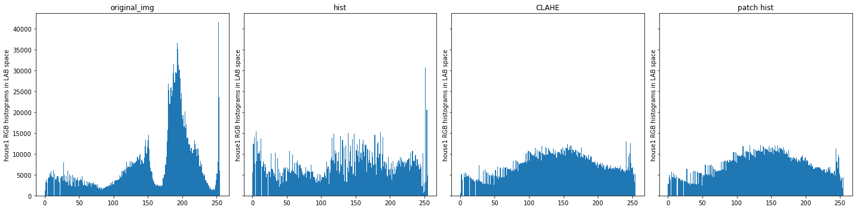

{'original_img': [1.0095479389173265], 'hist': [0.4546713721652889], 'CLAHE': [0.35524810363869486], 'patch hist': [0.3638056595445797]}

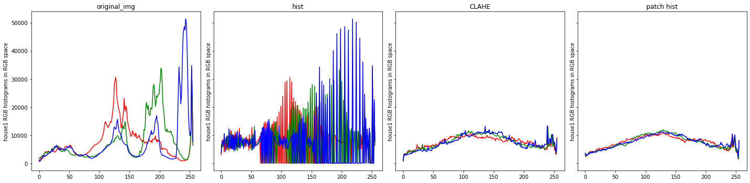

{'original_img': [0.78839934, 0.93128526, 1.2305193], 'hist': [0.8691389, 1.0142027, 1.2977047], 'CLAHE': [0.24797957, 0.3156013, 0.33436257], 'patch hist': [0.27216437, 0.32801154, 0.29485634]}

house2

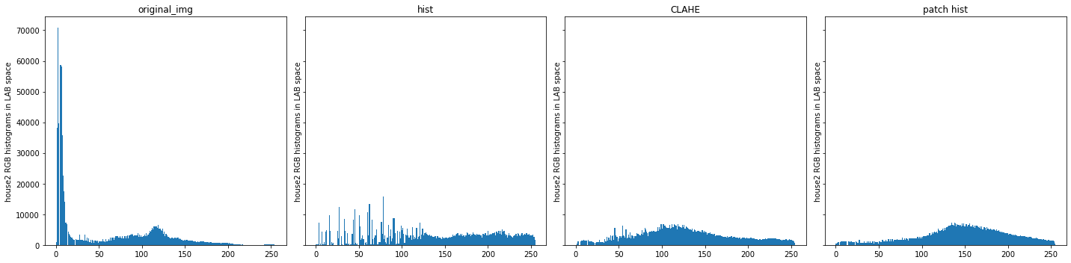

{'original_img': [2.580501310084254], 'hist': [0.7486384641842768], 'CLAHE': [0.5391628921323603], 'patch hist': [0.6425077805025328]}

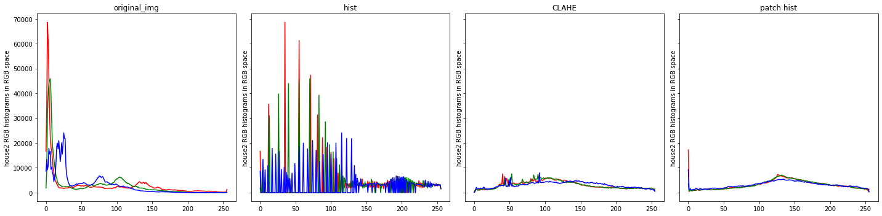

{'original_img': [2.3474143, 2.1443372, 1.5361768], 'hist': [2.3865113, 2.1696618, 1.5558996], 'CLAHE': [0.47622988, 0.51415, 0.3765655], 'patch hist': [0.6085616, 0.5546114, 0.41532704]}

for now it looks like CLAHE gives the smoothest histograms and first version of "patch hist" is a little rougher than it,

but both do much better job then global histogram equalization.

and (at least to me) CLAHE and "patch hist" emphasize the most details in the images.

Expansion of “patch hist” results

**Note:** because of the results above the deeper dive will focus on results on LAB images, but the same techniques can be done on any other color space.

Because "patch hist" works on every patch in the image, it have many data points on each pixel, so we can calculate more then just the mean of the distribution.

For now we will look at the standard deviation and skewness images that the deeper “patch hist” can gives us.

Standard Deviation images

Images

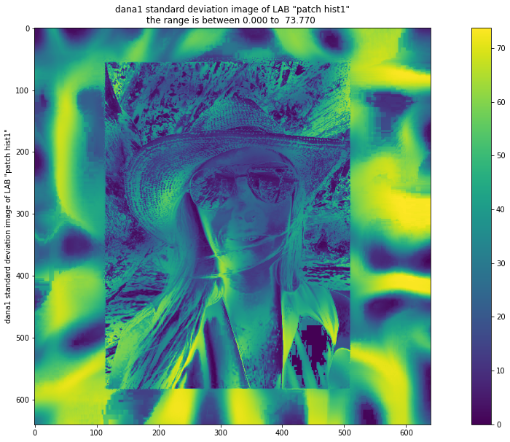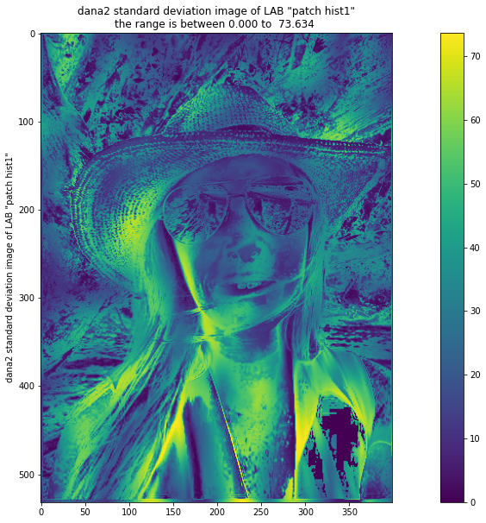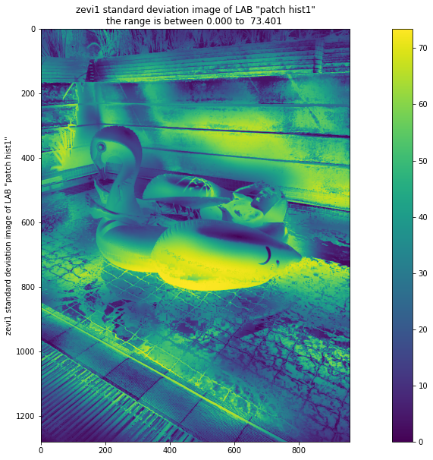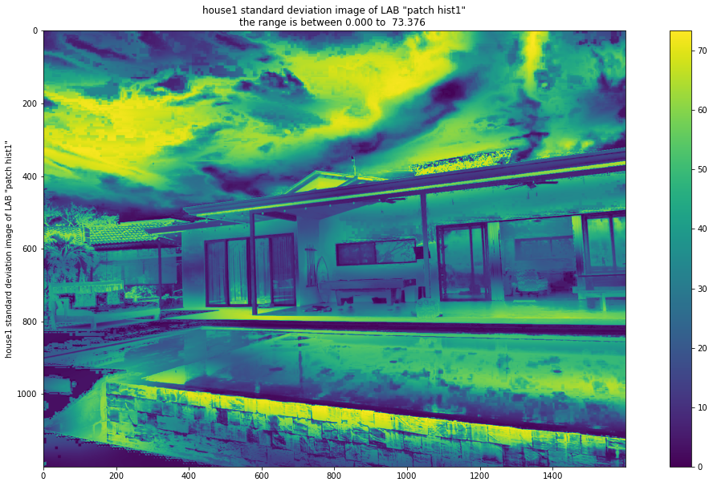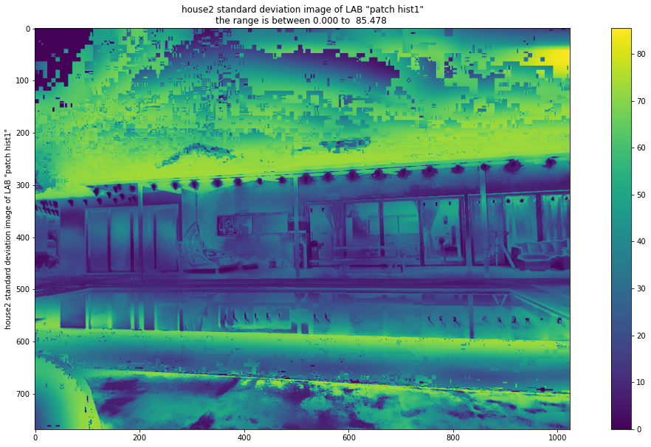

Histograms

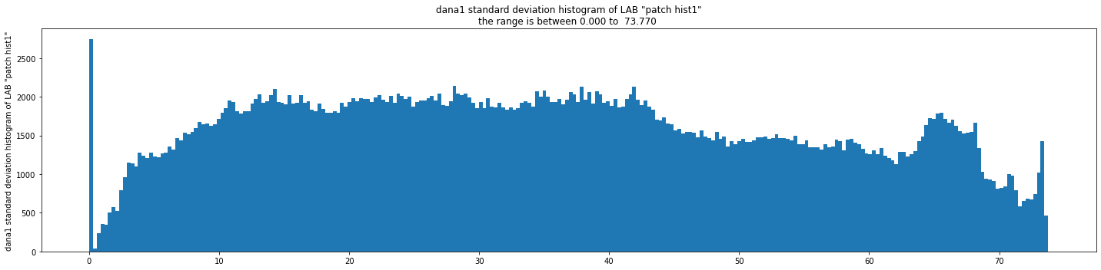

{'img_std_ph': [0.25805224411610794]}

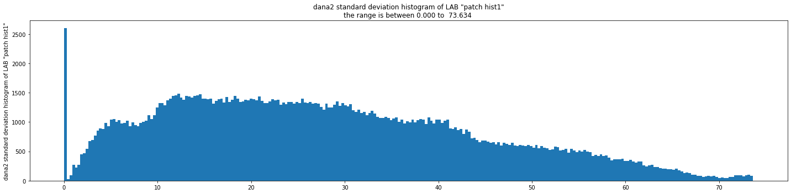

{'img_std_ph': [0.5649629417365025]}

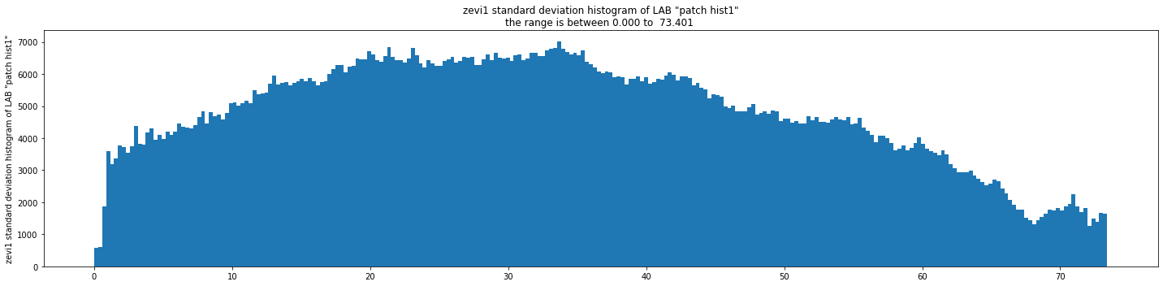

{'img_std_ph': [0.32831397346440117]}

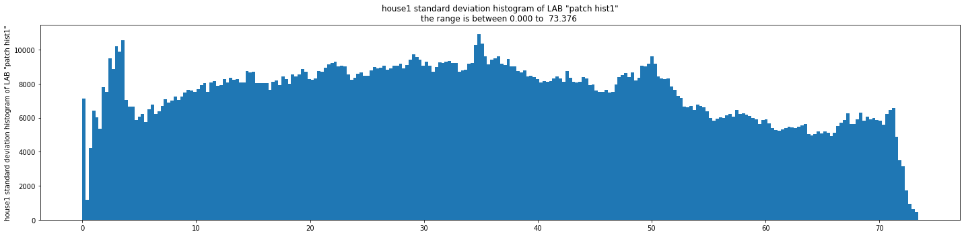

{'img_std_ph': [0.22796419248547686]}

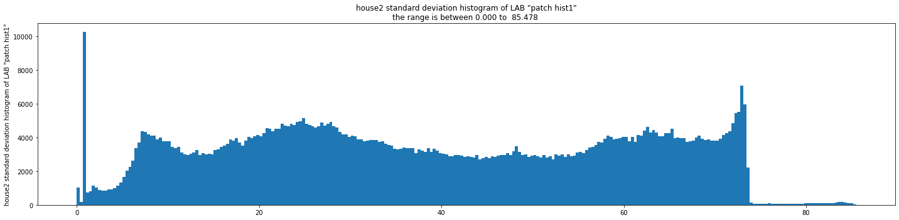

{'img_std_ph': [0.5052309621088696]}

It looks like for most images the standard deviation is distributed pretty uniformly between close to 0 up to about 70. but that says that the mean is not completely stable.

Skewness images

Images

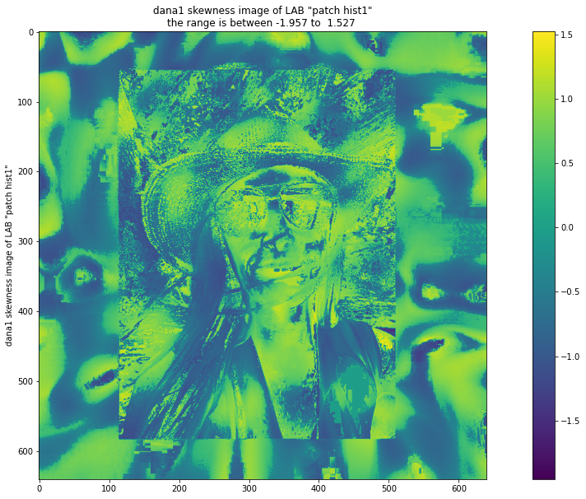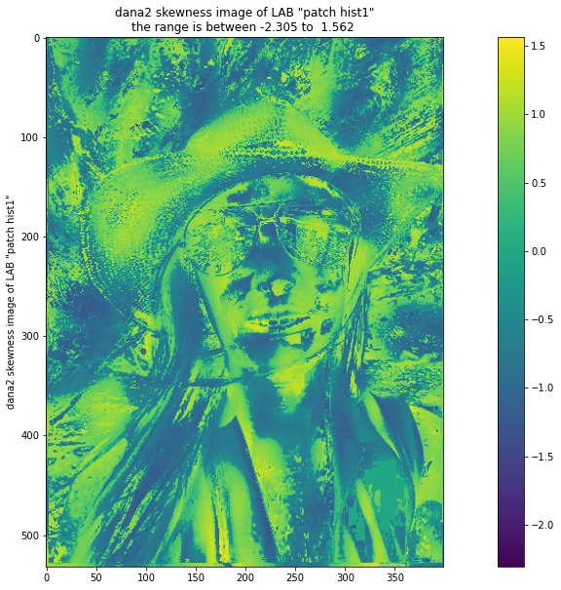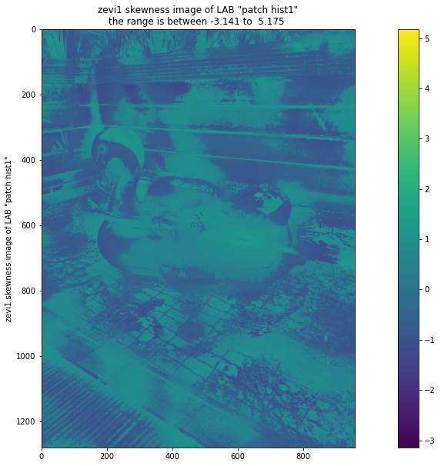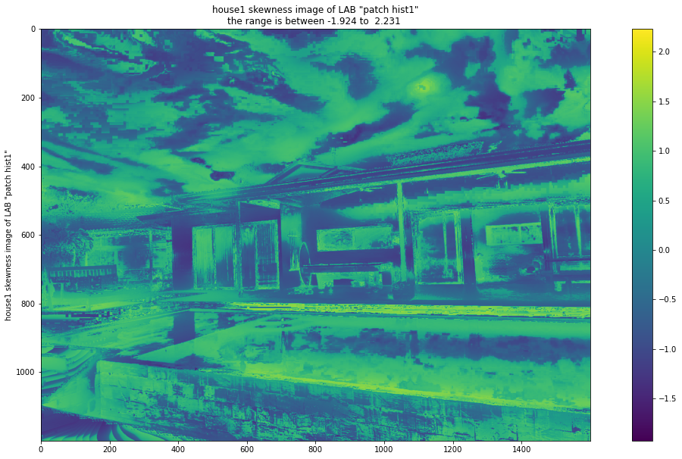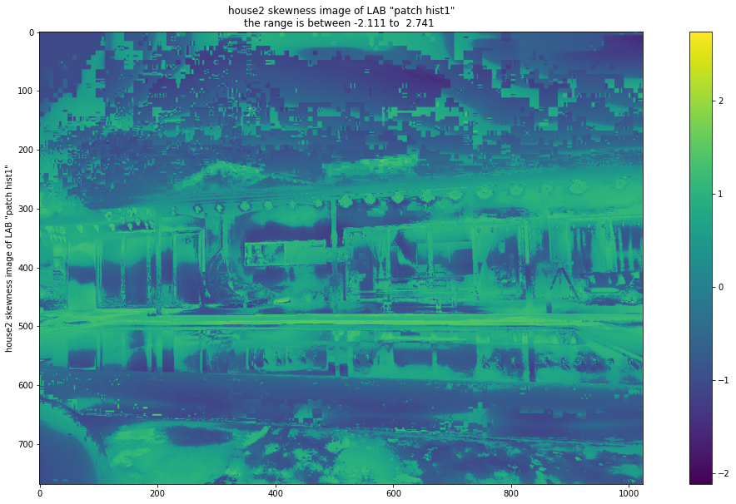

Histograms

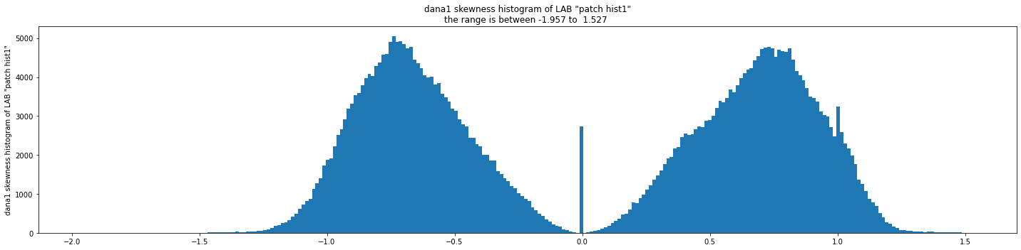

{'img_skew_ph': [1.0483205766816468]}

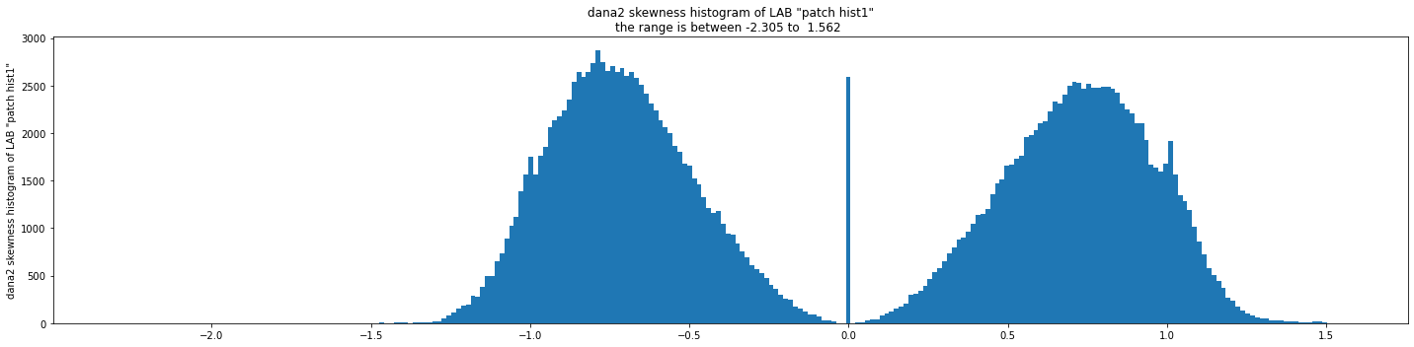

{'img_skew_ph': [1.1486925484172403]}

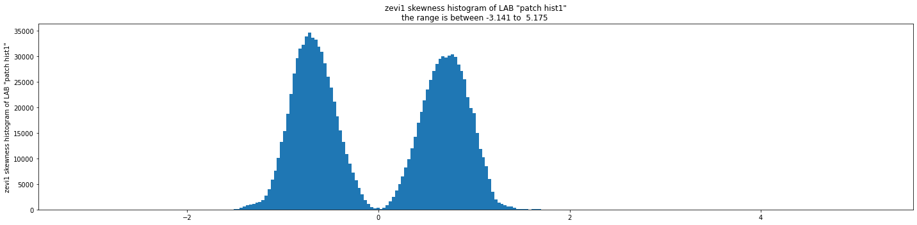

{'img_skew_ph': [1.984386101254627]}

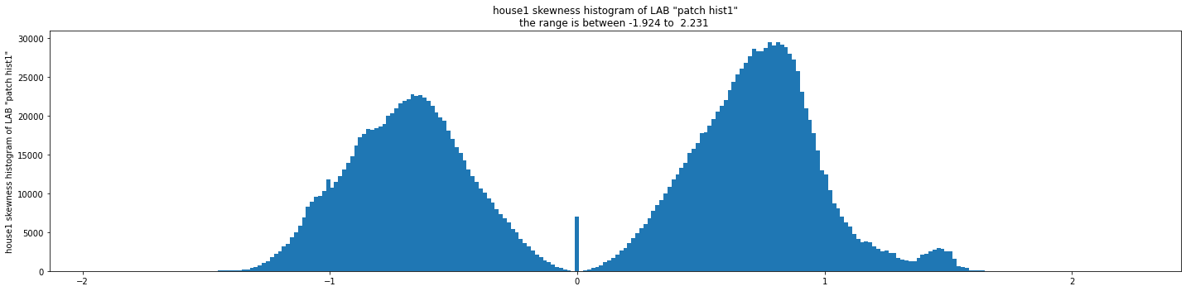

{'img_skew_ph': [1.1901940509382867]}

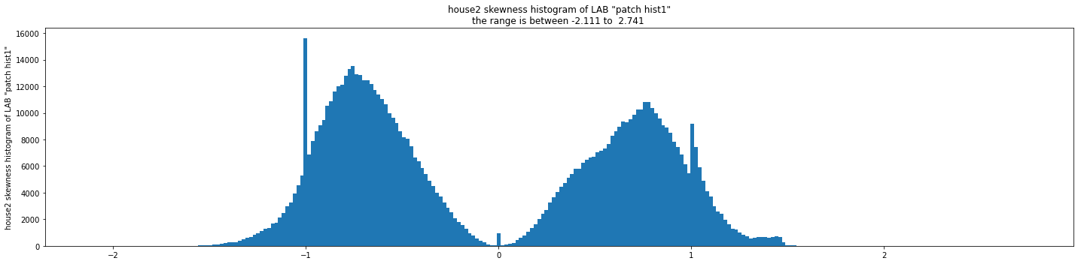

{'img_skew_ph': [1.3240394574059169]}

It looks like for most images the skewness is distributed in a double normal distributions with centers in about the +-0.75(mirrored on the 0 center). but that says that the distributions is mostly skewed and not normal.

standard deviation and skewness

Because the results above we want to see the joint distribution of the standard deviation and the skewness to see if it show us something special or more.

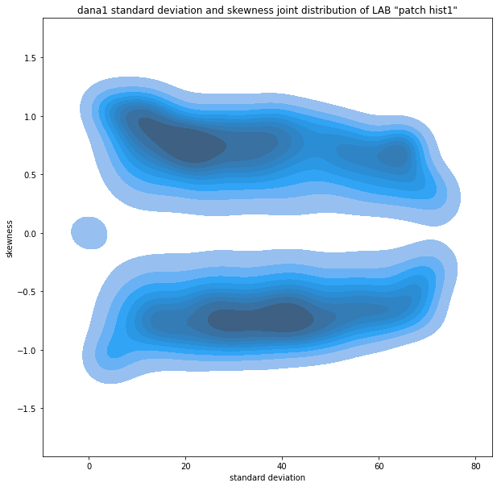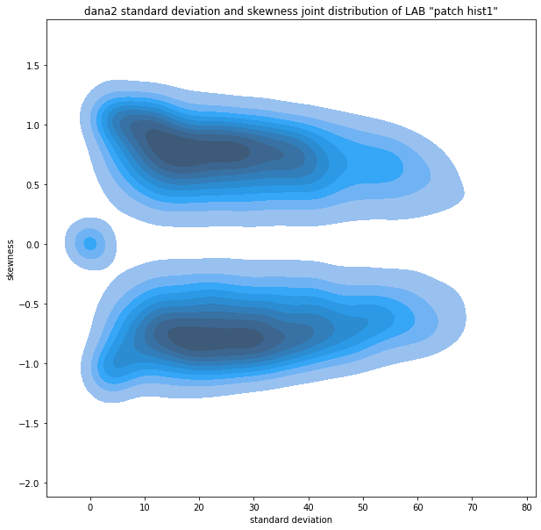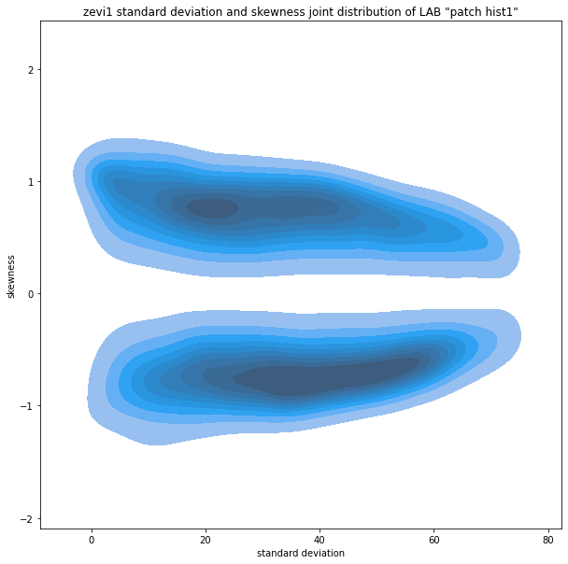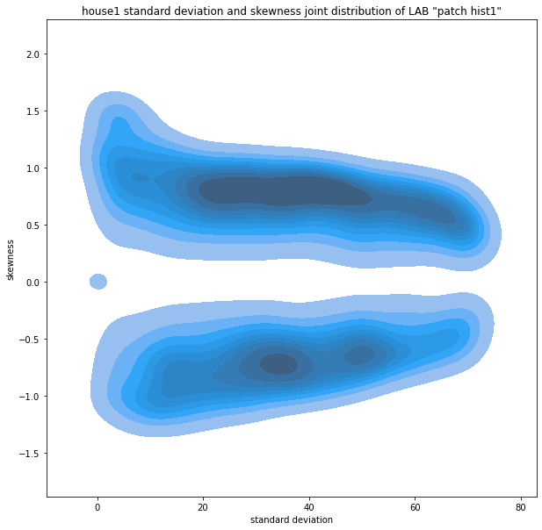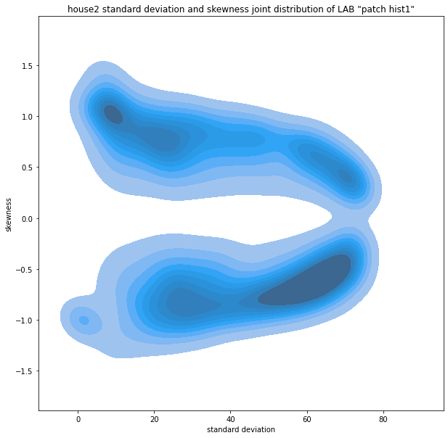

skewness correction

Finally, having calculated the mean image as well as the standard deviation image and the skewness image, we can now calculate a correction of the mean towards the median.

We will try a simple correction with the equation:

skew corrected image = mean - alpha * skew image * std image

And we will try and see several alphas

dana1 skew corrections

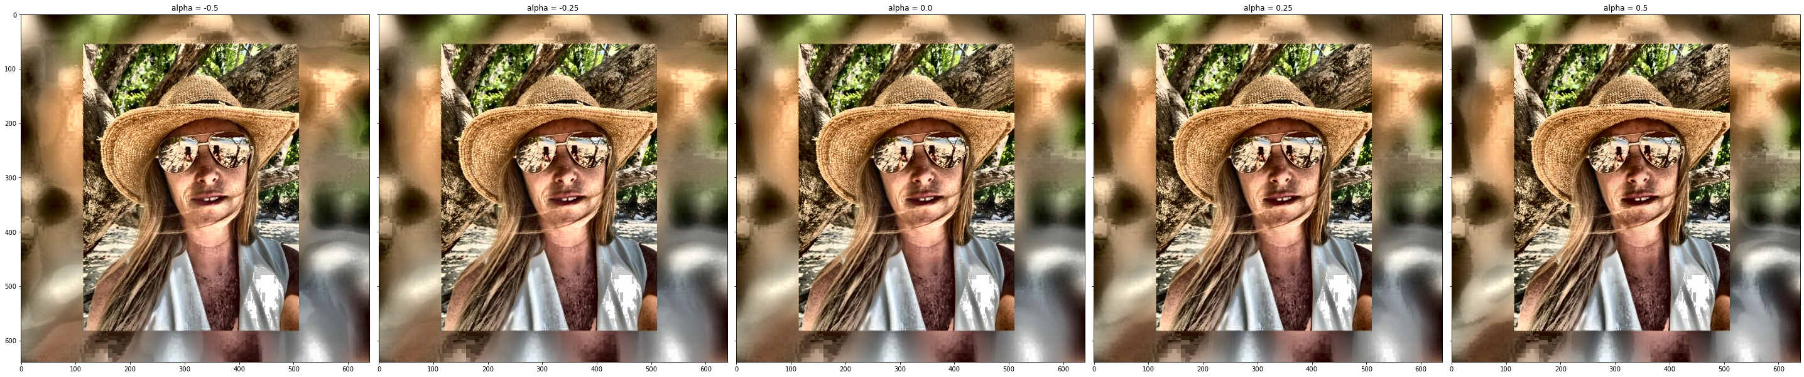

dana2 skew correction

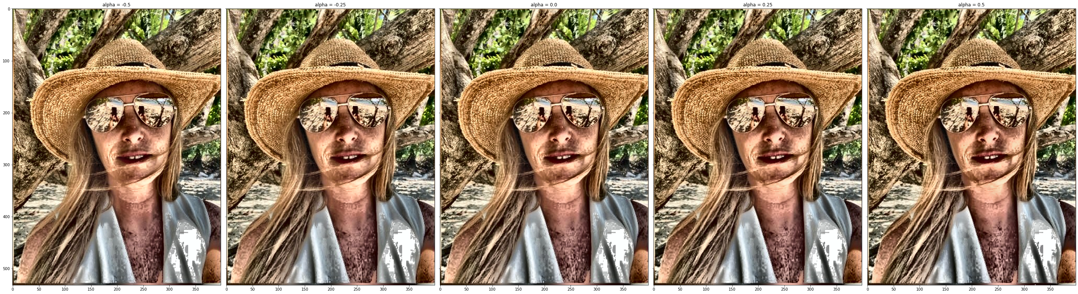

zevi1 skew correction

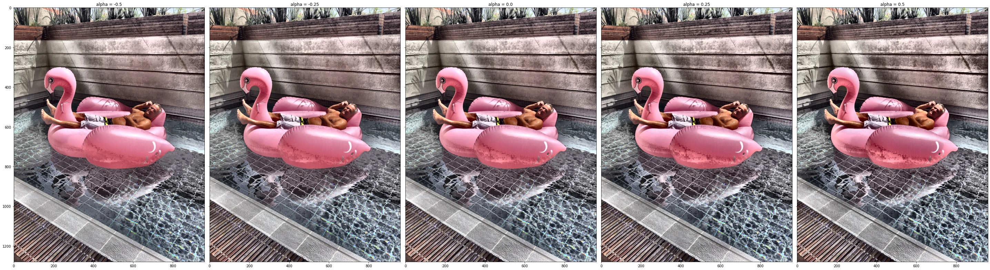

house1 skew correction

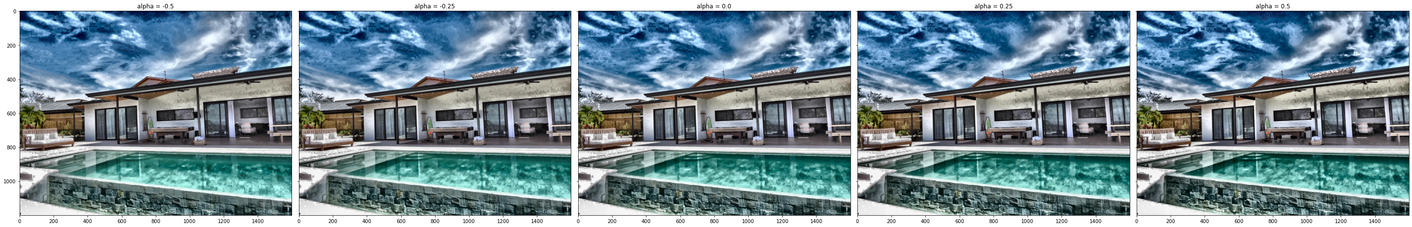

house2 skew correction

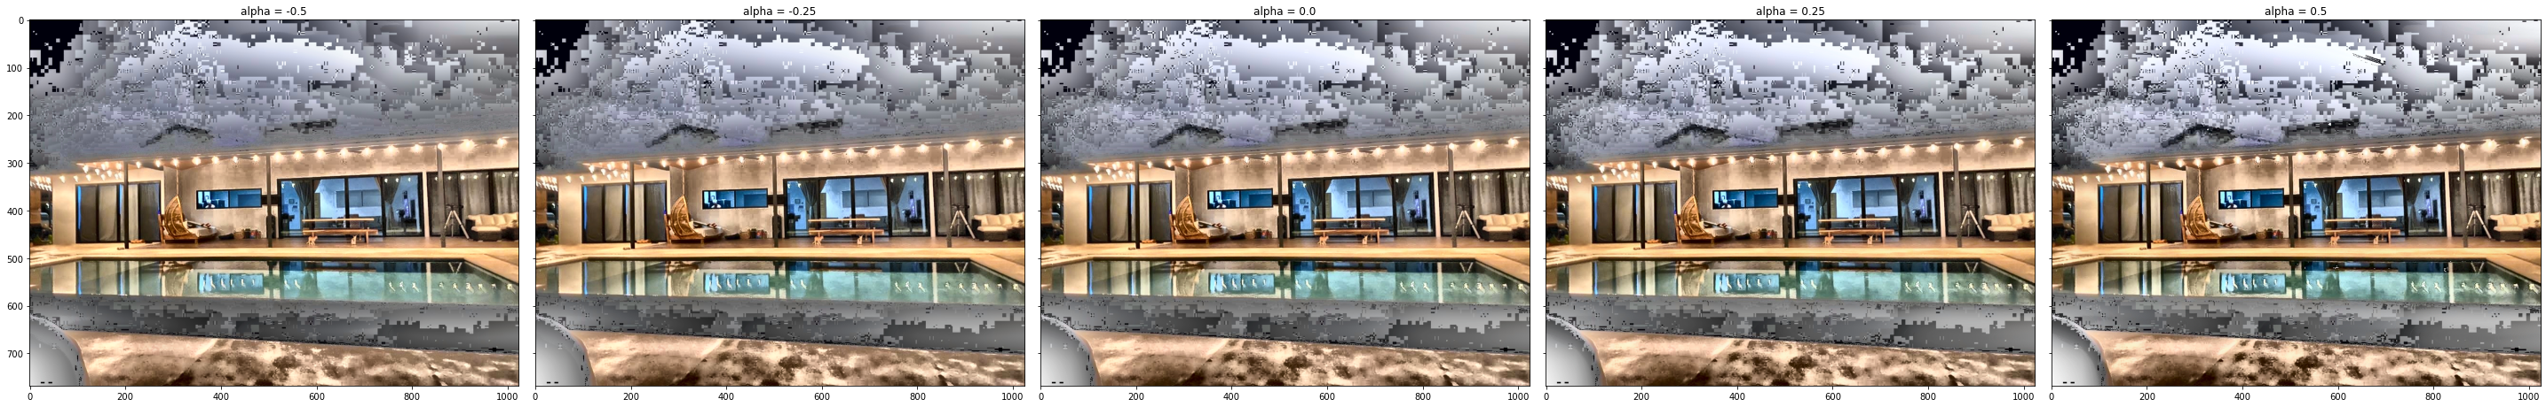

At least to my eyes the skewness correction may give a little more details enhancement but it does not strictly gives a better image.